This working version was developed using my own XAMPP web server because I still have trouble running scripts on the SLU server. Koutsougeras had an example working at time for me, but something caused it to be in error. I reproduced what he did, but I still get errors.

I can add a new user here. A user name and password are entered in this form…

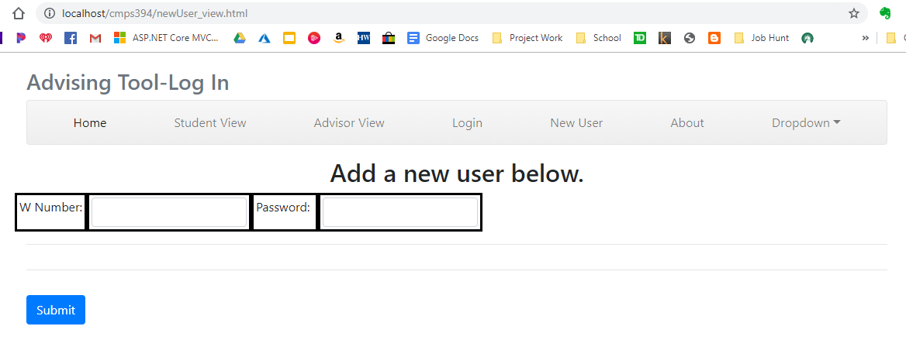

…and is handed off to addNewUser.cgi. it’s purpose is to take the inputs of the form and store a user name and password to a flat file named…

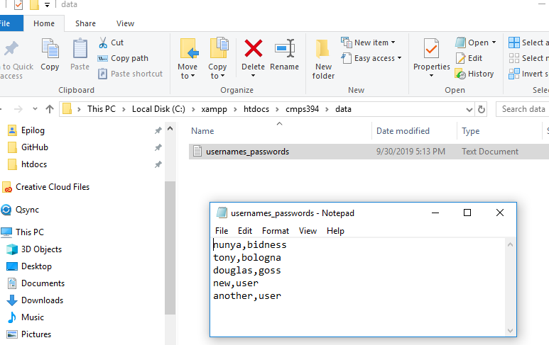

I can create a new user with no problem with my server.

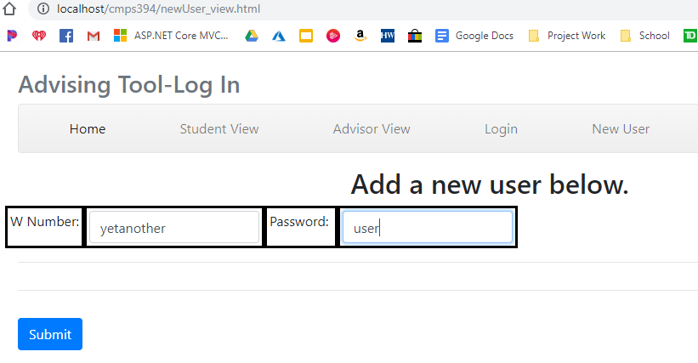

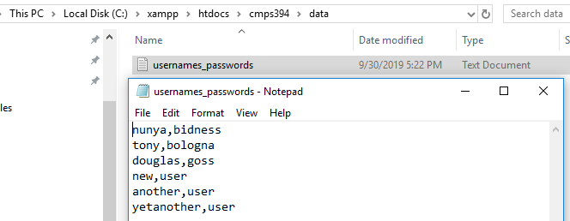

While I can read the contents of the usernames_passwords file with a test set up on login_view.html and it’s handler script login.cgi…

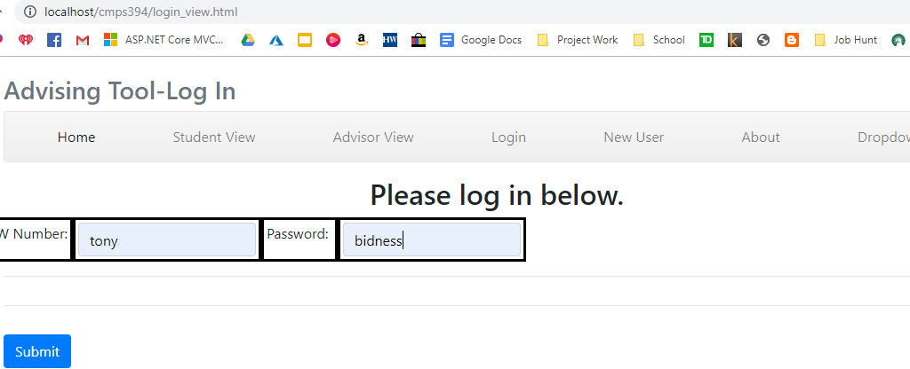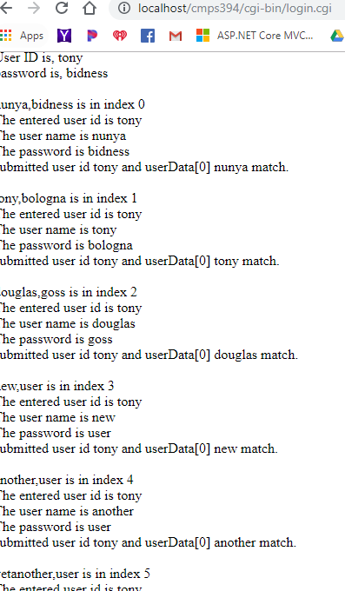

…I cannot do a comparison between the entered information from the form against the contents of the usernames_password.txt file for some unknown reason. This logic should work…

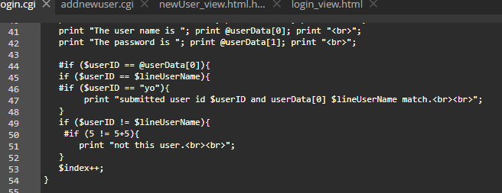

…but it does not. I’ve spent hours trying to get past the server problem and this comparison problem without much luck. I may have to take a hit at this point.

Came back the next morning and found where my comparison logic was wrong. I need to use eq for string equivalency comparisons. But, the comparison still isn’t working correctly.

When I log in with w1111111 and password…

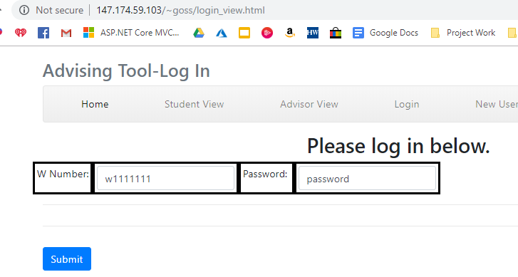

I should get that the password submitted through the form matches the password for user w1111111 in the database, but I am not.

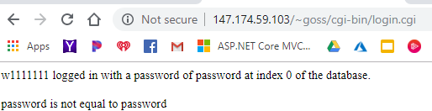

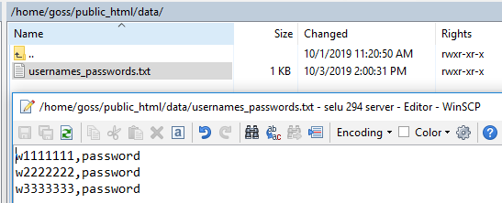

userData[0] is $userID and userData[1] is $password.

This is the logic I am using to test this functionality.

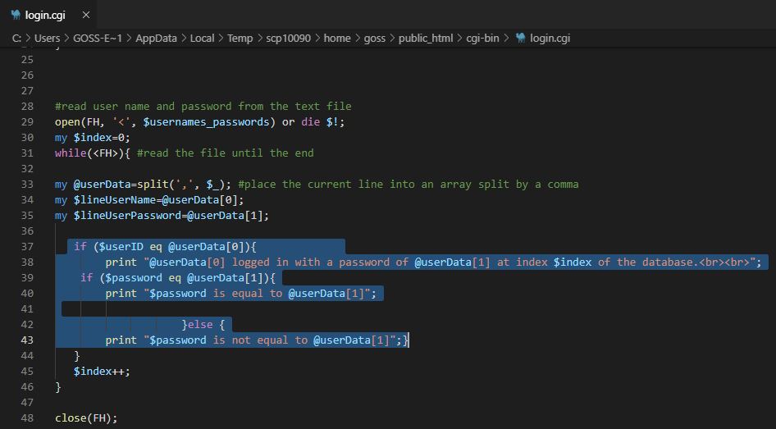

My files are located here on the SLU server.

